***What is Express?***

Express is same as jQuery in JS.

Node is like a screw once you build then you can create a lot of applications using it. 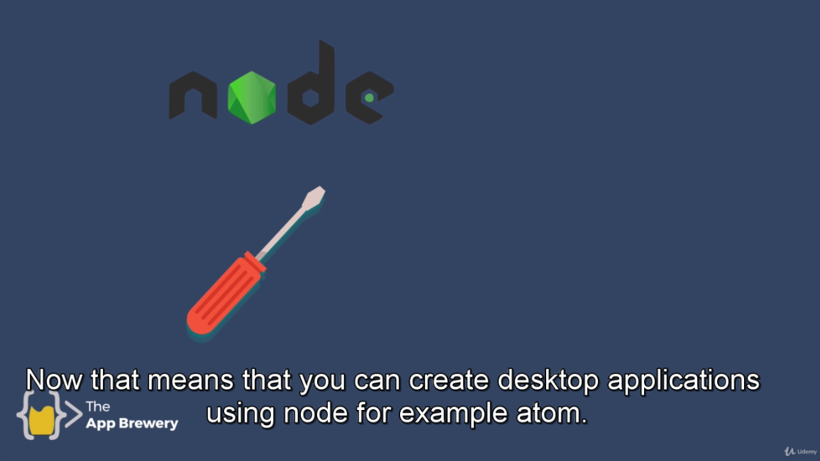

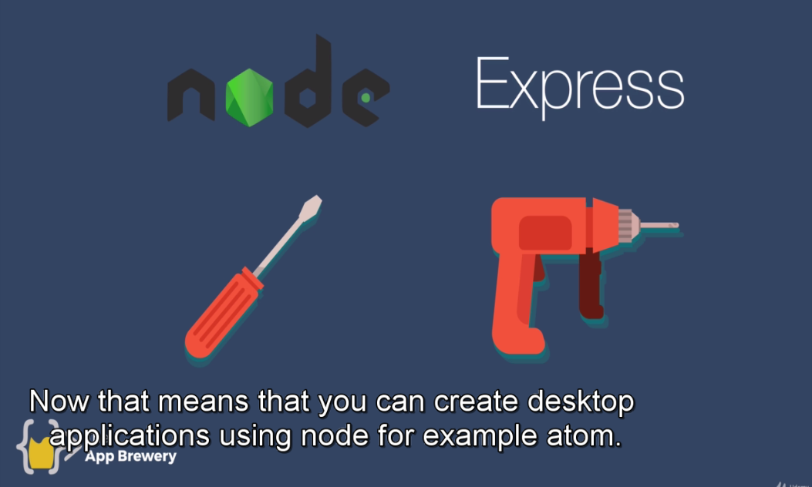

It allows you to remove repetitive code.

